41.40: The time required to transit the horizontal 50 cm region is
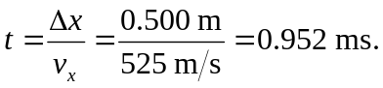
The force required to deflect each spin component by 0.50 mm is
According to Eq. 41.22, the value of 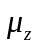 is
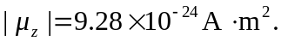
Thus, the required magnetic-field gradient is
